Independent submission to the
Office of the High Commissioner for Human Rights
on the situation of human rights in the Philippines
as requested by the Human Rights Council (the Council)
in its Resolution 41/2 adopted on 11 July 2019

Supplementary information on the
grave human rights violations resulting from women’s and girls’ lack of effective access to safe and legal abortion in the Philippines

Respectfully submitted on

January 31, 2020

By

Catholics for Reproductive Health
Center for Reproductive Rights
EnGendeRights, Inc.
Family Planning Organization of the Philippines
Filipino Freethinkers
Philippine Safe Abortion Network
WomanHealth Philippines
Women’s Clinic Pilipinas
Women’s Global Network for Reproductive Rights

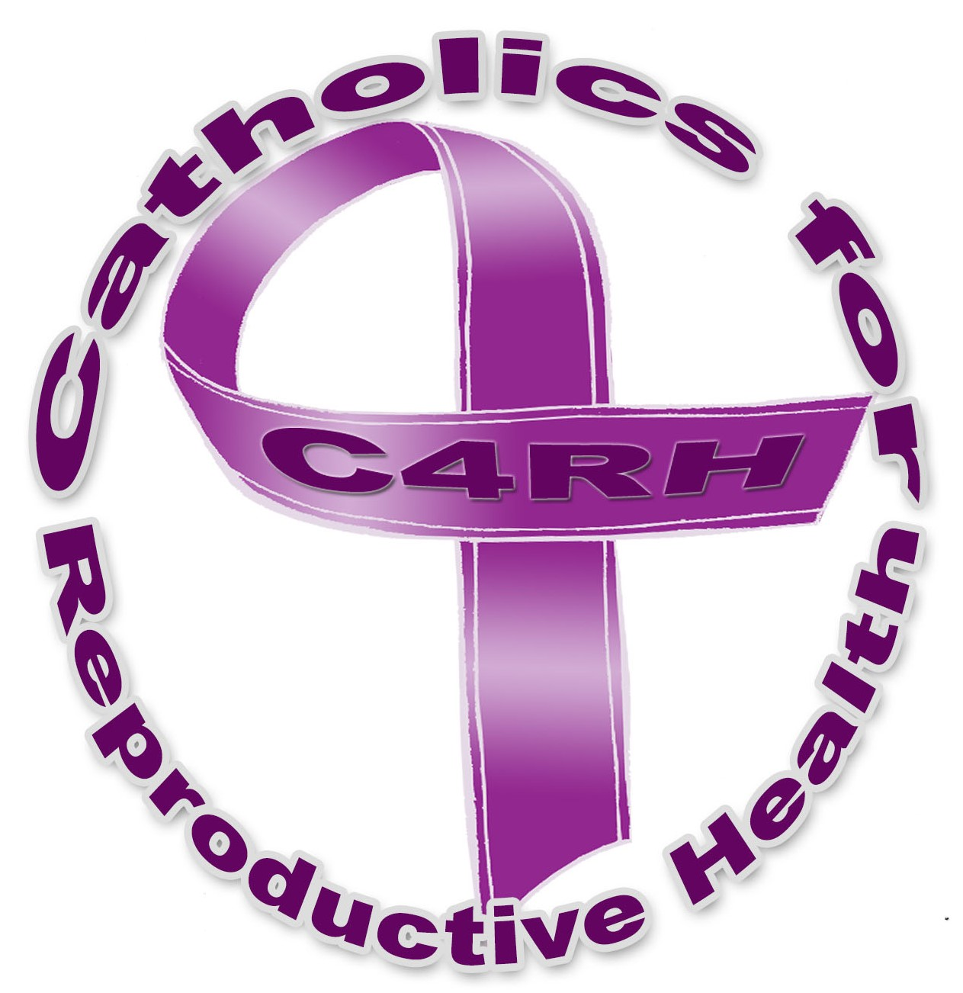
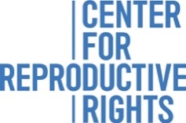
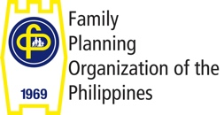

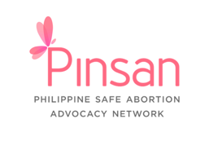
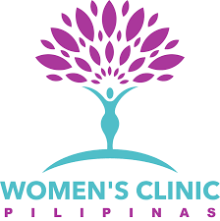
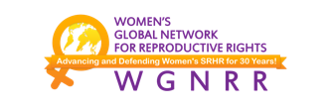

- This submission was prepared by a coalition of civil society groups working in the Philippines to contribute to the upcoming report of the Office of the High Commissioner for Human Rights (OHCHR) on the situation of human rights in the Philippines as requested by the Human Rights Council (the Council) in its Resolution 41/2 adopted on 11 July 2019 on the promotion and protection of human rights in the country. We would like to direct the attention of the OHCHR to grave violations of fundamental human rights resulting from one of the most restrictive abortion laws in the world which causes preventable deaths and injuries among women and girls who are unable to access safe and legal abortion services.

- OHCHR has expressed concern about total prohibitions on abortion, including specifically the impact on the prosecution and punishment of women for miscarriages and other obstetric emergencies, and called for governments’ compliance with international human rights standards and obligations by repealing such prohibitions. UN human rights experts have also called for governments to decriminalize abortion and recognize women’s right to reproductive autonomy as “[l]egal frameworks for abortion have typically been designed to control women's decision-making through the use of criminal law”. They recognized that restrictions to access abortion services disproportionately impact women and girls from marginalized groups such as those living in poverty, in rural areas, with disabilities, migrants, and those belonging to ethnic minorities or in situations of crisis. The UN Special Rapporteur on extrajudicial, summary or arbitrary executions specifically noted that “the death of a woman, where it can be medically linked to a deliberate denial of access to life-saving medical care” because of an absolute prohibition on abortion constitutes not only a “violation of the right to life and an arbitrary deprivation of life, [but also] a gender-based arbitrary killing, only suffered by women, as a result of discrimination enshrined in law.” She noted that, even in states where abortion are allowed in certain cases, it is more likely for women to seek unsafe abortion and suffer life-threatening consequences because of “[t]he uncertainty surrounding the process of establishing whether a woman’s pregnancy poses a risk to her life, the reticence of the medical profession in the absence of transparent and clearly defined procedures to determine whether the legal conditions for a therapeutic abortion are met, along with the threat of criminal prosecution.”

- The Revised Penal Code of 1930 (RPC) provides for the penal provisions on abortion and imposes prison sentences up to 6 years for an individual found guilty of performing or providing assistance to an abortion with the consent of the woman, or on the woman herself having an abortion. It is a draconian law which is largely based on the Spanish Penal Code of 1870. The specific penal provisions on abortion are grossly antiquated as they can be further traced to the older Spanish Penal Codes of 1848 and 1822. Despite the archaic nature of its laws as well as the continuing violations of women’s and girls’ fundamental rights by the denial of safe and legal abortion services, the Government has not taken any steps to repeal or amend these discriminatory provisions. Often, if not always, the Government justifies its inaction by asserting a narrow interpretation of the constitutional provision that requires the state to “equally protect the life of the mother and the life of the unborn from conception”. While the Constitution does not expressly prohibit access to abortion and may be interpreted to allow abortion in certain circumstances, including at a minimum when the life or physical and mental health of a woman or girl is at risk, the Supreme Court (the Court) narrowly described in passing the said policy as a “constitutional policy prohibiting abortion” which wholly ignores women’s fundamental rights equally protected under the Constitution. This makes the Philippines an outlier in a global context in which countries with similar constitutional provisions nevertheless permit abortion on certain grounds. This restrictive interpretation causes difficulty in accessing safe and legal abortion even when necessary to save one’s life. The story of Haydee illustrates this—

Haydee, a married mother of one living in a poor, urban, and informal settlement in Manila City, developed severe hypertension during her first pregnancy. During her second pregnancy, she suffered a stroke that ultimately led to the termination of her pregnancy. Because of her medical history, Haydee was warned not to become pregnant again because it could be fatal. Due to financial and practical barriers in accessing contraceptives suitable to her medical condition, Haydee experienced two subsequent unintended pregnancies. Despite the fatal condition of her pregnancies, private doctors denied her request for an abortion on both occasions because they said it was a “sin.” Haydee was forced to resort to self-induce an abortion by taking misoprostol at home without medical guidance. While the first abortion did not result in any serious complications, her subsequent attempt caused heavy bleeding for more than four weeks. When Haydee sought medical treatment at a government hospital, the staff coerced her into admitting that she had induced the abortion, scolded her for committing a “sin” and “killing her own child,” and threatened to report her to the police.

- The country’s restrictive abortion laws remain without any clear exceptions. While a liberal interpretation of such laws allow certain cases of abortion and the Government has recently reported to the Human Rights Committee that abortion to “protect the life and health of the pregnant woman” may be justified under the country’s penal laws, women and girls still can neither freely seek nor immediately access abortion on any grounds because of lack of specific regulations. Fears of arrests and prosecutions widespread given the regular media reports of women seeking abortions and people providing or assisting them being arrested. Even women who have not intentionally terminated their pregnancies, like Diane below, face suspicion of violating the RPC and are often denied the necessary medical care—

Diane was repeatedly beaten by her partner. During one assault, her partner kicked her abdomen while she was six months pregnant. Several weeks after the incident, Diane suspected that something was wrong with her pregnancy. When she consulted a private clinic, she learned that the fetus had died in utero and she urgently needed a procedure to avoid sepsis. She requested the termination at four different government hospitals and was refused every time for varying reasons. Some staff members inaccurately considered the evacuation of the fetus as an abortion that is prohibited under the law. Others suspected that Diane had induced an abortion and was therefore not deserving of proper care. There were also staff who did not categorize her condition as an emergency in need of urgent treatment. A private birthing home finally accepted her and agreed to clandestinely provide medical care without maintaining any records of the procedure.

- The criminalization of abortion has not prevented women and girls from seeking and accessing it. Abortion is common in the Philippines: latest estimates indicate that around 610,000 induced, and potentially unsafe, abortions took place in the Philippines in 2012, an increase from 560,000 in 2008. While abortion is a safe medical procedure when done according to the World Health Organization’s standards, legal restrictions cause many women in the Philippines to suffer life-threatening complications. Induced abortion is one of the leading causes of maternal deaths in the Philippines. The number of women hospitalized for abortion complications increased from 90,000 in 2008 to 100,000 in 2012. These numbers can be expected to continue rising as the Philippine population and demand for services increases. Common complications of unsafe abortion include blood loss, hemorrhage, sepsis, infection, perforation of the uterus, damage to other internal organs, and death. An estimated 1,000 maternal deaths were attributed to abortion complications in 2008 translating to around three women dying every day as a result of unsafe abortions. In a 2017 report, the Government noted that the maternal mortality ratio (MMR) in 2015 is 204 per 100,000 live births which failed to meet the MMR target under the Millennium Development Goals (52 per 100,000 live births by 2015) and is far from the target under the Sustainable Development Goals (70 per 100,000 live births by 2030). Pregnant women who are poor, with more children, and those burdened with household chores and tasked with child care are more likely not to seek services from a health care facility and therefore suffer from deaths and complications. As admitted by the Government, leading causes of maternal deaths are “preventable and can be averted by quality obstetrics care.” One of the thousands of women who died from preventable causes is Maricel who desperately tried several ineffective means to terminate her pregnancy—

Maricel, an 18-year-old mother of one, tragically died after she delayed seeking lifesaving medical attention for abortion complications because she feared the law and being punished. She was granted a visa to work abroad as a domestic worker, and became pregnant when breastfeeding failed as a method of contraception. She tried to induce an abortion to avoid jeopardizing her employment. Unfortunately, her efforts led to fatal complications, which if treated immediately could have saved her life.

- UN human rights bodies have repeatedly urged the Government to amend its law on abortion. In 2015, the Committee on the Elimination of Discrimination against Women (CEDAW Committee) expressed concerns on the unsafe abortions and unnecessary and preventable maternal deaths in the country and called for the Government to “legalize abortion in cases of rape, incest, threats to the life and/or health of the pregnant woman, or serious malformation of the fetus, the decriminaliz[ation] of all other cases where women undergo abortion, and the adopt[ion] of necessary procedural rules to guarantee effective access to legal abortion”. In 2016, the Committee on Economic, Social, and Cultural Rights (ESCR Committee) urged the Government to “take all measures necessary to reduce the incidence of unsafe abortion and maternal mortality including through amending its legislation on the prohibition of abortion to legalize abortion in certain circumstances.” Also in 2016, the Committee against Torture (CAT Committee) called for a review of the RPC “to allow for legal exceptions…in specific circumstances such as when the pregnancy endangers the life or health of the woman, when it is the result of rape or incest and in cases of foetal impairment.” The recommendations to review the current laws on abortion have been echoed by the Philippine Commission on Human Rights.

- United Nations bodies have found that restrictive abortion laws violate a range of human rights, including the rights to life, health, privacy, freedom from gender discrimination or gender stereotyping, and freedom from ill-treatment. UN treaty-monitoring bodies (TMBs) have repeatedly recognized the connection between restrictive abortion laws, high rates of unsafe abortion and maternal mortality. The CEDAW Committee has found that denying women access to certain reproductive health services or punishing women for seeking those services is a form of gender discrimination. Recognizing these human rights violations, UN bodies have called on states to decriminalize abortion in all circumstances, and ensure certain legal grounds for abortion, at a minimum, when a woman’s life or health is at risk, in cases of rape and incest, and in cases of severe or fatal fetal impairments. Further, they have urged states to eliminate punitive measures for women who undergo abortions and for health care providers who deliver abortion services, finding that criminalization of these services is a form of discrimination and a violation of the rights to health, life, and freedom from torture or ill-treatment.

- Forcing a woman or girl to undergo an unsafe abortion is a violation of her right to life which is protected under various international human rights treaties as well as Philippine national laws and policies. Government are obliged to prevent women and girls from having to resort to clandestine and unsafe abortions that endanger their lives. In its General Comment on the right to life, the Human Rights Committee stated that while states may regulate abortion, it “must not result in violation of the right to life of a pregnant woman or girl, or her other rights under the [ICCPR]” such as her right to privacy, equality and non-discrimination, and to be free from torture and ill-treatment. It prohibits regulations that force women to undergo an unsafe abortion which includes “apply[ing] criminal sanctions against women and girls undergoing abortion or against medical service providers assisting them in doing so.” The story of Mylene, a twenty-six year old doctor, who became pregnant after being raped, further reflects how lives are lost when access to abortion is restricted—

Faced with an unwanted pregnancy and unable to legally obtain an abortion, Mylene confided in almost no one and decided to self-induce an abortion. She developed a severe infection and sought treatment in a public hospital where her doctor-friend worked. She had a bruise on her abdomen and cotton fibers inside her vagina. She experienced severe abdominal pain and a dilation and curettage was eventually performed on her. Tragically, Mylene died on the operating table due to renal failure from sepsis caused by the unsafe abortion.

- Restrictive abortion laws have also long been characterized as a violation of women’s right to health. Treaty monitoring bodies have noted that, like other reproductive health services, legal abortion services must be available, accessible, affordable, acceptable, and of good quality and have even urged states to liberalize their abortion laws to improve access including for adolescents. According to the Committee on the Rights of the Child (CRC Committee), adolescents should have access to safe abortion and post-abortion care, regardless of the legal status of abortion. In the country where written parental consent is required before minors can access contraceptives, their access to abortion and post-abortion care is similarly, if not further, restricted.

- As found by the Human Rights Committee, in certain circumstances, denial of access to abortion services lead to physical or mental suffering that amounts to ill-treatment. The Special Rapporteur on the right to the highest standard of physical and mental health reported that “[t]he intense stigmatization of both the abortion procedure and women who seek such procedures can have deleterious effects on women’s mental health.” Particularly in jurisdictions where abortion is penalized, “the overarching threat of being investigated, prosecuted and punished within the criminal justice system has significant negative impacts on the emotional health and well-being of both those who seek abortions and those who do not.” The Special Rapporteur on torture also noted that, “[t]he denial of safe abortions and subjecting women and girls to humiliating and judgmental attitudes in such contexts of extreme vulnerability and where timely health care is essential amount to torture or ill-treatment.” He further expressed concern on the “[l]imited and conditional access to abortion-related care, especially where this care is withheld for the impermissible purpose of punishing or eliciting a confession.” He also expressly recognized that “[t]he practice of extracting, for prosecution purposes, confessions from women seeking emergency medical care as a result of illegal abortion in particular amounts to torture or ill-treatment.” The story of Kaye demonstrates how women are subjected to torture or ill-treatment under the country’s abortion laws—

Terrified and hemorrhaging after taking an unregistered drug to induce an abortion, Kaye, a young woman from Manila, sought medical treatment at a government hospital. Instead of prompt and compassionate care, she was verbally abused by the staff and had to wait for almost 24 hours before receiving life-saving treatment for her complications. Hospital workers refused to provide treatment until Kaye admitted that she had self-induced an abortion. After the forced confession, she was immediately reported to the police by hospital staff. Police officers came to the hospital and brought Kaye to jail, where she was charged and detained for illegally inducing abortion.

- Applicable to Kaye’s case is the observation of UN experts that “health-care providers tend to exercise considerable authority over clients, placing women in a position of powerlessness, while the lack of legal and policy frameworks that effectively enable women to assert their right to access reproductive health services enhances their vulnerability to torture and ill-treatment”. The CAT Committee has expressed that women are particularly vulnerable in situations relating to their reproductive decisions. The CAT and CEDAW Committees also found that delaying safe abortion or post-abortion care is a form of gender-based violence, which may even amount to torture or cruel, inhuman or degrading treatment.

- As a signatory to major international human rights treaties, the Government is obliged to respect, protect, and fulfil the rights to life, health, equality and non-discrimination, privacy, and freedom from torture and ill-treatment of Haydee, Diane, Maricel, Kaye, Mylene, and the hundreds of thousands of women and girls in the country who are in need of and seek access to abortion every year. We urge the OHCHR to call on the Government to immediately address the grave human rights violations caused by its restrictive legal framework on abortion including by taking steps to:
  - decriminalize abortion in all cases;
  - ensure access to quality abortion services when necessary to protect the life or health of the pregnant woman or girl as a recognized legal ground for abortion by issuing evidence-based guidelines and training for healthcare professionals on providing such services; and
  - ensure that women and girls are able to access quality post-abortion care in all public and private health facilities regardless of the legal status of abortion.

If you have any questions or would like further information, please do not hesitate to contact Jihan Jacob of the Center for Reproductive Rights at jjacob@reprorights.org.

See e.g. Statement by UN High Commissioner for Human Rights Zeid Ra’ad Al Hussein at the end of his mission to El Salvador, U.N. Human rights Office of the High Commissioner (Nov. 17, 2017), https://www.ohchr.org/EN/NewsEvents/Pages/DisplayNews.aspx?NewsID=22412&LangID=E. In October 2016, OHCHR presented amicus curiae in regards to the Zika virus in Latin America, when denial of abortion reached the threshold of torture and inhuman or degrading treatment. In 2017, OHCHR also submitted an amicus curiae to the Interamerican Commission on Human Rights in regards to the laws on abortion in El Salvador.
States must act now to allow safe, legal abortions for women and girls, say UN rights experts, United Nations Human rights Office of the High Commissioner (Sep. 27, 2018), https://www.ohchr.org/EN/NewsEvents/Pages/DisplayNews.aspx?NewsID=23646&LangID=E.
International Safe Abortion Day September 28, 2019: All states must ensure access to safe and legal abortion as a matter of human rights, say UN experts, U.N. Human rights Office of the High Commissioner (Sep. 27, 2019), https://www.ohchr.org/EN/NewsEvents/Pages/DisplayNews.aspx?NewsID=25066&LangID=E.
Special Rapporteur on extrajudicial, summary or arbitrary executions, Report of the Special Rapporteur on extrajudicial, summary or arbitrary executions on a gender-sensitive approach to arbitrary killings, para. 94, U.N. Doc. A/HRC/35/23 (June 6, 2017) (by Agnes Callamard).
Id. at para. 95.
Phil. Revised Penal Code (Act No. 3815), arts. 256-259 (1930) [hereinafter Rev. Penal Code].
Codigò Penal, arts. 425-428 (Spain) (1870), available at https://bit.ly/2Pq3Kf9
Codigò Penal, arts. 376, 639-640 (Spain) (1822), available at https://bit.ly/2RXVGE0; Codigò Penal, arts. 337-340 (Spain) (1848), available at https://bit.ly/2tnyfKe.
Phil. Const. (1987), art. II, sec. 12.
See Center for Reproductive Rights, Realizing a Healthy, Equal, and Thriving Philippines: The Role of Abortion Law Reform in Achieving the Nation’s Development Goals, 2 (2018) [hereinafter Legislative brief on Abortion in the Philippines].
James M. Imbong and Lovely-Ann C. Imbong v. Hon. Paquito N. Ochoa, Jr. and Others, G.R. Nos. 204819, 204934, 204957, 204988, 205003, 205043, 205138, 205478, 205491, 205720, 206355, 207111, 207172 and 207563, (S.C., Apr. 8, 2014) (Phil.) [hereinafter Imbong v. Ochoa].
See e.g. The Constitution of The Philippines, 1987, art. II, secs. 1, 5, 9, 11, 14, 15, art. XIII, secs. 1, 11, 12, 14.
States whose constitutions contain protections for the life of the unborn but permit abortion in certain circumstances include Kenya, Hungary, Costa Rica, Republic of Ireland, Slovak Republic and Poland. See Const., arts. 26 (2), (4) (2010) (Kenya); A Magyar Köztársaság Alkotmánya [Constitution of the Republic of Hungary] (2011), art. II; Law on the Protection of Fetal Life (Act LXXIX of 1992) (Hung.); Const. (1949), title IV, art. 21 (Costa Rica); Código Penal (Penal Code) No. 4573, art. 121, May 4, 1970 (Costa Rica); Ir. Const., 1937, art. 40 (3.3); Attorney General v X and Others, [1992] 1 I/R/ 846P (Ir.); Nález Ústavného súdu Slovenskej republiky, sp. zn. [Decision of the Constitutional Court of the Slovak Republic, No. PL. ÚS 12/01-297] (Dec. 4, 2007) (unofficial translation on file with the Center for Reproductive Rights), Const. (1997), art. 38 (Pol.).
The names of all women in this submission have been changed to protect their identity. Center for Reproductive Rights, Forsaken Lives: the Harmful Impact of the Philippine Criminal Abortion Ban, 39-40 (2010) [hereinafter Forsaken Lives].
Human Rights Committee, Fifth periodic report submitted by the Philippines under article 40 of the Convention to the Human Rights Committee due in 2016, para. 34, U.N. Doc. CCPR/C/PHL/5, received by the Committee on 31 May 2019.
See e.g. Arrested for abortion, TEMPO (July 31, 2013), http://www.tempo.com.ph/2013/07/31/arrested-for-abortion/; Ed Mahilum, 92-year-old abortionist arrested, MANILA BULLETIN (Oct. 1, 2013), http://www.mb.com.ph/92-year-old-abortionist-arrested/; Aie Balagtas See, Woman nabbed for abortion, THE PHILIPPINE STAR (July 12, 2015), http://www.philstar.com/metro/2015/07/12/1475986/woman-nabbed-abortion; 4 pinaghihinalaang abortionist arestado sa Maynila, ABS-CBN News (June 18, 2018), https://bit.ly/2SXMBZQ; Angel Movido, Babae, arestado sa pagbebenta ng mga gamot na umano’y pampalaglag, ABS-CBN News (Mar. 30, 2018), https://bit.ly/2PPZ1Es.
Center for Reproductive Rights, Documentation Report: Focus Group Discussion on Post-abortion care (2014), on file with the Center for Reproductive Rights [hereinafter Focus Group Discussion on Post-abortion care] (A birthing home is a facility that provides birthing service on prenatal and post-natal care, normal spontaneous delivery, and care of newborn babies). See also, Department of Health Admin. Order No. 0012 (2012), Rules and Regulations Governing the New Classification of Hospital and Other Health Facilities in the Philippines (July 2012), art. 2.
Lawrence B. Finer Et Al., Guttmacher Institute, Unintended Pregnancy and Unsafe Abortion in the Philippines: Context and Consequences, In Brief No. 3, at 3, (2013) [hereinafter Guttmacher Institute, Unintended Pregnancy (2013)], available at http://www.guttmacher.org/pubs/IB-unintended-pregnancy-philippines.pdf.
World Health Organization, Fact Sheet: Preventing Unsafe Abortion (2018) [hereinafter WHO, Preventing Unsafe Abortion (2018)].
Millennium Development Goal 5: UNDP in Philippines, United Nations Development Programme, http://www.ph.undp.org/content/philippines/en/home/mdgoverview/overview/mdg5/; Committee on the Elimination of Discrimination against Women, Summary of the inquiry concerning the Philippines under article 8 of the Optional Protocol to the Convention on the Elimination of All Forms of Discrimination against Women, para. 33, U.N. Doc. CEDAW/C/OP.8/PHL/1 (Apr. 22, 2015) [hereinafter CEDAW Committee, Inquiry Report].
Lawrence B. Finer Et Al., Guttmacher Institute, Unintended Pregnancy and Unsafe Abortion in the Philippines: Context and Consequences, In Brief No. 3 (2013) [hereinafter Guttmacher Institute, Unintended Pregnancy (2013)].
Philippine Statistics Authority, Updated Population Projections based on the Results of 2015 POPCEN, Annex A: Technical Notes, Oct. 4, 2019, available at https://psa.gov.ph/content/updated-population-projections-based-results-2015-popcen (The mid-year population projections by assumption levels and population census counts is 101,264,000 in 2015 [low assumption] increasing to 115, 378,000 in 2025 [low assumption]).
Forsaken Lives, supra note 14, at 14; Guttmacher Institute, Unintended Pregnancy (2013), supra note 21.
Guttmacher Institute, Unintended Pregnancy (2013), supra note 21, citing Guttmacher Institute, Meeting Women’s Contraceptive Needs in the Philippines, In Brief 2009 Series No. 1, (2009) available at https://www.guttmacher.org/pubs/2009/04/15/IB_MWCNP.pdf.
Philippines Department of Health and Philippines Commission on Population, 3rd Annual Report on the Implementation of the Responsible Parenthood and Reproductive Health Act of 2012, 5 & 17 (2017), available at https://bit.ly/2vC4A0m.
Id.
U.N. General Assembly Res. 16/35, Transforming our world: the 2030 Agenda for Sustainable Development, A/RES/70/1 (21 October 2015).
Commission on Population, Precious and Precarious: The Life of Filipino Mothers, State of Population Report, at 6 and 24 (2015) available at http://popcom.gov.ph/state-of-the-philippine-population-report/.
Philippines Department of Health and Philippines Commission on Population, 4th Annual Report on the Implementation of the Responsible Parenthood and Reproductive Health Act of 2012, 33 (2018), available at https://bit.ly/2veVweu.
Forsaken Lives, supra note 14, at 11.
Id. at paras. 33, 51 (e).
Committee on Economic, Social and Cultural Rights, Concluding Observations: Philippines, para. 51, U.N. Doc. ESCR/C.12/PHL/CO/5-6 (2016).
Committee Against Torture, Concluding Observations: Philippines, paras. 39-40, U.N. Doc. CAT/C/PHL/CO/3 (2016) [hereinafter CAT Committee (2016)].
Philippine Commission on Human Rights and United Nations Population Fund (UNFPA), Let Our Voices Be Heard: Report Of The Commission on Human Rights Philippines’ National Inquiry on Reproductive Health and Rights, 29 (2016) [hereinafter Let Our Voices Be Heard]..
See, e.g., K.L. v. Peru, Human Rights Committee, Commc’n No. 1153/2003, U.N. Doc. CCPR/C/85/D/1153/2003 (2005); L.C. v. Peru, CEDAW Committee, Commc’n No. 22/2009, para. 8.15, U.N. Doc. CEDAW/C/50/D/22/2009 (2011).
See, e.g., Committee on the Elimination of Discrimination against Women, Concluding Observations: Paraguay, paras. 30, 31, U.N. Doc. CEDAW/C/PRY/CO/6 (2011); Committee on the Elimination of Discrimination against Women, Concluding Observations: Chile, paras. 34, 35, U.N. Doc. CEDAW/C/CHI/CO/5-6 (2012); ESCR Committee, Concluding Observations: Philippines, paras. 51, 52, U.N. Doc. E/C.12/PHL/CO5-6 (2016); Human Rights Committee, Concluding Observations: Zambia, para. 18, U.N. Doc. CCPR/C/ZMB/CO/3 (2007).
CEDAW Committee, Gen. Recommendation No. 24: Article 12 of the Convention (Women and Health), paras. 11, 14, U.N. Doc. A/54/38/Rev. 1 (1999) [hereinafter CEDAW Committee, Gen. Recommendation No. 24].
See Committee on the Rights of the Child, Concluding Observations: Bhutan, para. 35(c), U.N. Doc. CRC/C/BTN/CO/3-5 (2017); Committee on the Rights of the Child, Concluding Observations: Cameroon, para. 35(c), CRC/C/CMR/CO/3-5 (2017); Committee on the Rights of the Child, Concluding Observations: Sierra Leone, para. 32 (c), U.N. Doc. CRC/C/SLE/CO/3-5 (2016); Committee on the Rights of the Child, Concluding Observations: Benin, para. 57(c), U.N. Doc. CRC/C/BEN/CO/3-5 (2016); CEDAW Committee, Concluding Observations: Micronesia, para. 37(b), U.N. Doc. CEDAW/C/FSM/CO/1-3 (2017); CEDAW Committee, Concluding Observations: Niger, para. 33(c), U.N. Doc. CEDAW/C/NER/CO/3-4 (2017); CEDAW Committee, Concluding Observations: Costa Rica, para. 31(a), U.N. Doc. CEDAW/C/CRI/CO/7 (2017). See also Human Rights Committee, Concluding Observations: Honduras, para. 17, U.N. Doc. CCPR/C/HND/CO/2 (2017).
See, e.g., L.C. v. Peru, CEDAW Committee, Commc’n No. 22/2009, para. 12(b), U.N. Doc. CEDAW/C/50/D/22/2009 (2011); K.L. v. Peru, Human Rights Committee, Commc’n No. 1153/2003, U.N. Doc. CCPR/C/85/D/1153/2003 (2005); Human Rights Committee, Concluding Observations: Ireland, para. 9, U.N. Doc. CCPR/C/IRL/CO/4 (2014); CEDAW Committee, Concluding Observations: Bahrain, para. 42(b), U.N. Doc. CEDAW/C/BHR/CO/3 (2014); CAT Committee, Concluding Observations: Paraguay, para. 22, U.N. Doc. CAT/C/PRY/CO/4-6 (2011); CRC Committee, Concluding Observations: Chile, para. 61, U.N. Doc. CRC/C/CHL/CO/4-5 (2015); Costa Rica, para. 64, U.N. Doc. CRC /C/CRI/CO/4 (2011); Dominican Republic, para. 52, U.N. Doc. CRCC/DOM/CO/3-5; ESCR Committee, Concluding Observations: Chile, para. 29, U.N. Doc. E/C.12/CHL/CO/4 (2015).
See, e.g., CEDAW Committee, Gen. Recommendation No. 24, supra note 37, at para. 14; CRC Committee, Concluding Observations: Nicaragua, para. 59, U.N. Doc. CRC/C/NIC/CO/4 (2010); CAT Committee, Concluding Observations: Nicaragua, para. 16, U.N. Doc. CAT/C/NIC/CO/1 (2009); ESCR Committee: Concluding Observations: Pakistan, paras. 77, 78, U.N. Doc. CESCR/C/PAK/CO/1 (2017).
See Universal Declaration of Human Rights, adopted Dec. 10, 1948, art. 3, G.A. Res. 217A (III), U.N. Doc. A/810 at 71 (1948) (“Everyone has the right to life, liberty and security of person”); see International Covenant on Civil and Political Rights, adopted Dec. 16, 1966, art. 6, para. 1, G.A. Res. 2200A (XXI), U.N. GAOR, 21st Sess., Supp. No. 16, U.N. Doc. A/6316 (1966), 999 U.N.T.S. 171 (entered into force Mar. 23, 1976) (“Every human being has the inherent right to life. This right shall be protected by law. No one shall be arbitrarily deprived of his life.”); see also, Convention on the Rights of the Child, adopted Nov. 20, 1989, art. 6, para. 1, G.A. Res. 44/25, annex, U.N. GAOR, 44th Sess., Supp. No. 49, U.N. Doc. A/44/49 (1989) (entered into force Sept. 2, 1990); Phil. Const. (1987), art. III, sec. 1.
Human Rights Committee, General Comment No. 36 (2018) on article 6 of the International Covenant on Civil and Political Rights, on the right to life , U.N. Doc. CCPR/C/GC/36 (2018), para. 8 [hereinafter Human Rights Committee, Gen. Comment No. 36 ].
Id.
Forsaken Lives, supra note 14, at 49-50, 63, citing Metro Manila-based NGO, Interview with Dr. Sam, Metro Manila (Dec. 10, 2009).
See, e.g., L.C. v Peru, CEDAW Committee, Commc’n No. 22/2009, para. 8.15, U.N. Doc. CEDAW/C/50/D/22/2009 (2011); CEDAW Committee, Concluding Observations: Chile, para. 228, U.N. Doc. A/54/38/Rev.1(SUPP) (1999); CEDAW Committee, Concluding Observations: Paraguay, para. 131, U.N. Doc. A/51/38(SUPP) (1996).
See, e.g., ESCR Committee, General Comment No. 14: The right to the highest attainable standard of health (Art. 12 of the Covenant), para. 12, U.N. Doc. E/C.12/2000/4 (Aug. 11 2011); K.L. v. Peru, Human Rights Committee, Commc’n No. 1153/2003, U.N. Doc. CCPR/C/85/D/1153/2003 (2005); L.M.R. v. Argentina, Human Rights Committee, Commc’n No. 1608/2007, U.N. Doc. CCPR/C/101/D/1608/2007 (2011); L.C. v. Peru, CEDAW Committee, Commc’n No. 22/2009, U.N. Doc. CEDAW/C/50/D/22/2009 (2011).
ESCR Committee, General Comment No. 22: On the right to sexual and reproductive health (Art. 12), para. 28, U.N. Doc. E/C.12/GC/22 (May 2 2016).
CRC Committee, General. Comment No. 15 (2013) on the right of the child to the enjoyment of the highest attainable standard of health (Art. 24), para. 70, U.N. Doc. (CRC/C/GC/15); CRC Committee, General Comment No. 20 (2016) on the implementation of the rights of the child during adolescence, paras. 39, 60, U.N. Doc CRC/C/GC/20. (States are urged to consider establishing a legal presumption stating that adolescents are competent to seek and have access to sexual and reproductive health commodities and services, including abortion)
Imbong v Ochoa, supra note 11. See also An Act Providing for a National Policy on Responsible Parenthood and Reproductive Health, Rep. Act No. 10354 (2012) (Phil.), sec. 7 [hereinafter RPRHA].
See e.g., K.L. v. Peru, Human Rights Committee, Commc’n No. 1153/2003, paras. 6.3-6.6, 7, U.N. Doc. CCPR/C/85/D/1153/2003 (2005); L.M.R. v. Argentina, Human Rights Committee, Commc’n No. 1608/2007, para. 9.2, U.N. Doc. CCPR/C/101/D/1608/2007 (2011); Mellet v. Ireland, Human Rights Committee, Commc’n No. 2324/2013, paras. 7.6, 7.7, 7.8, U.N. Doc. CCPR/C/116/2324/2013 (2016); Whelan v. Ireland, Human Rights Committee, Commc’n No. 2425/2014, paras. 7.7, 7.8, 7.9, 7.12, U.N. doc. CCPR/C/119/D/2425/2014 (2017).
Special Rapporteur on the right to the highest attainable standard of physical and mental health, Interim report of the Special Rapporteur on the right of everyone to the enjoyment of the highest attainable standard of physical and mental health, para. 36, A/66/254 (2011).
Id.
Id. at para. 44.
Id.
Id.
Center for Reproductive Rights, Criminalization of Abortion in the Philippines Fact Sheet (2017), https://reproductiverights.org/document/criminalization-of-abortion-in-the-philippines-fact-sheet.
Special Rapporteur on torture and other forms of cruel, inhuman and degrading treatment, Report of the Special Rapporteur on torture and other cruel, inhuman or degrading treatment or punishment, para. 42, U.N. Doc. A/HRC/31/57 (2016).
CAT Committee, General Comment No. 2 on implementation of article 2 by States parties, para. 22.
See CAT Committee, Concluding Observations: Peru, para. 19, U.N. Doc. CAT/C/PER/CO/5-6, (2012); CAT Committee, Concluding Observations: Czech Republic, para. 12, U.N. Doc. CAT/C/CZE/CO/4-5 (2012); CEDAW Committee, General Recommendation No. 35 on gender-based violence against women, updating General Recommendation No. 19, para.18, U.N. Doc. CEDAW/C/GC/35 (2017).

